Ideation Phase Define the Problem Statements
Date | 24 September 2026
Team ID | SWTID-2026-6228
Project Name | AI BlogNest API
Maximum Mark | 2 Marks

Customer Problem Statement Template
Prepare a clear problem statement to understand the needs, difficulties, and expectations of your customers. This template helps you identify the main issues that customers experience while using a product or service.
A clear customer problem statement helps you and your team develop suitable solutions for customer needs. It also encourages you to understand the situation from the customer’s perspective and learn how they feel and think about the product or service.
By understanding the customer’s problems clearly, you can create better experiences and provide solutions that are more useful and satisfying.
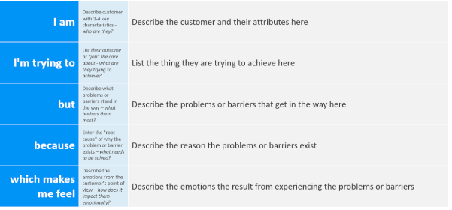Example:
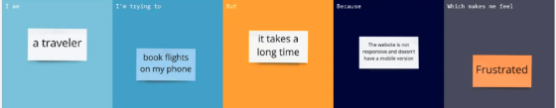
Problem Statement (PS) | I am (Customer) | I’m trying to | But | Because | Which makes me feel
PS-1
PS-2

